Ref.: AI/M/ADV/158/087 Date – ………………..

To
………………..

“Request Letter For Full Page Advertisement
In Awaaz India Magazine Coming Issue”
Sir,
Awaaz India – Monthly English Magazine. The Socio-Political and economic content, as you must have read , are comprehensive. “Awaaz India” is sworn to interpret every event , in subsequent issues.
It would be unfair to advertisers if we don’t read the leaders of industry , the bigwigs of business and jurists, Academician and policy-makers. After all, we shall be covering Commerce and Trade , Arts and Culture , Entertainment and Electronics , Aviation and Tourism , Famine and Floods, Health an Environment, Agriculture and Rural Development, Banking and Finance , Power and Petroleum , Education and Sport, Railway and Road Transport, Labor, Steel Coal and Mines. Our coverage will also include news, views and in-depth analysis of National and International events.

Advertising once in our extra large size magazine would be equivalent to sending out multiple message. Try us out. The instant response would be the proof . We have an all India circulation network . With RNI (Registered Newspaper of India) summated Annual Circulation in 2015 – 2016 and including complimentary copies and with estimated readership of 2 lakh yearly to all the Very important people and commercially important people at the center and in the states of the country wise.

As we expect and early response from you, may we reiterate that our ‘product is multi-colored’ and dynamically done up, our tariff is competitive. In fact, long-term arrangement with us would be unbelievably inexpensive.
The tariff is being enclosed for your kind consideration & perusal. We are flexible in our approach, if your need are specific. Trust us to promote your image.
Thanking you,

Your’s faithfully

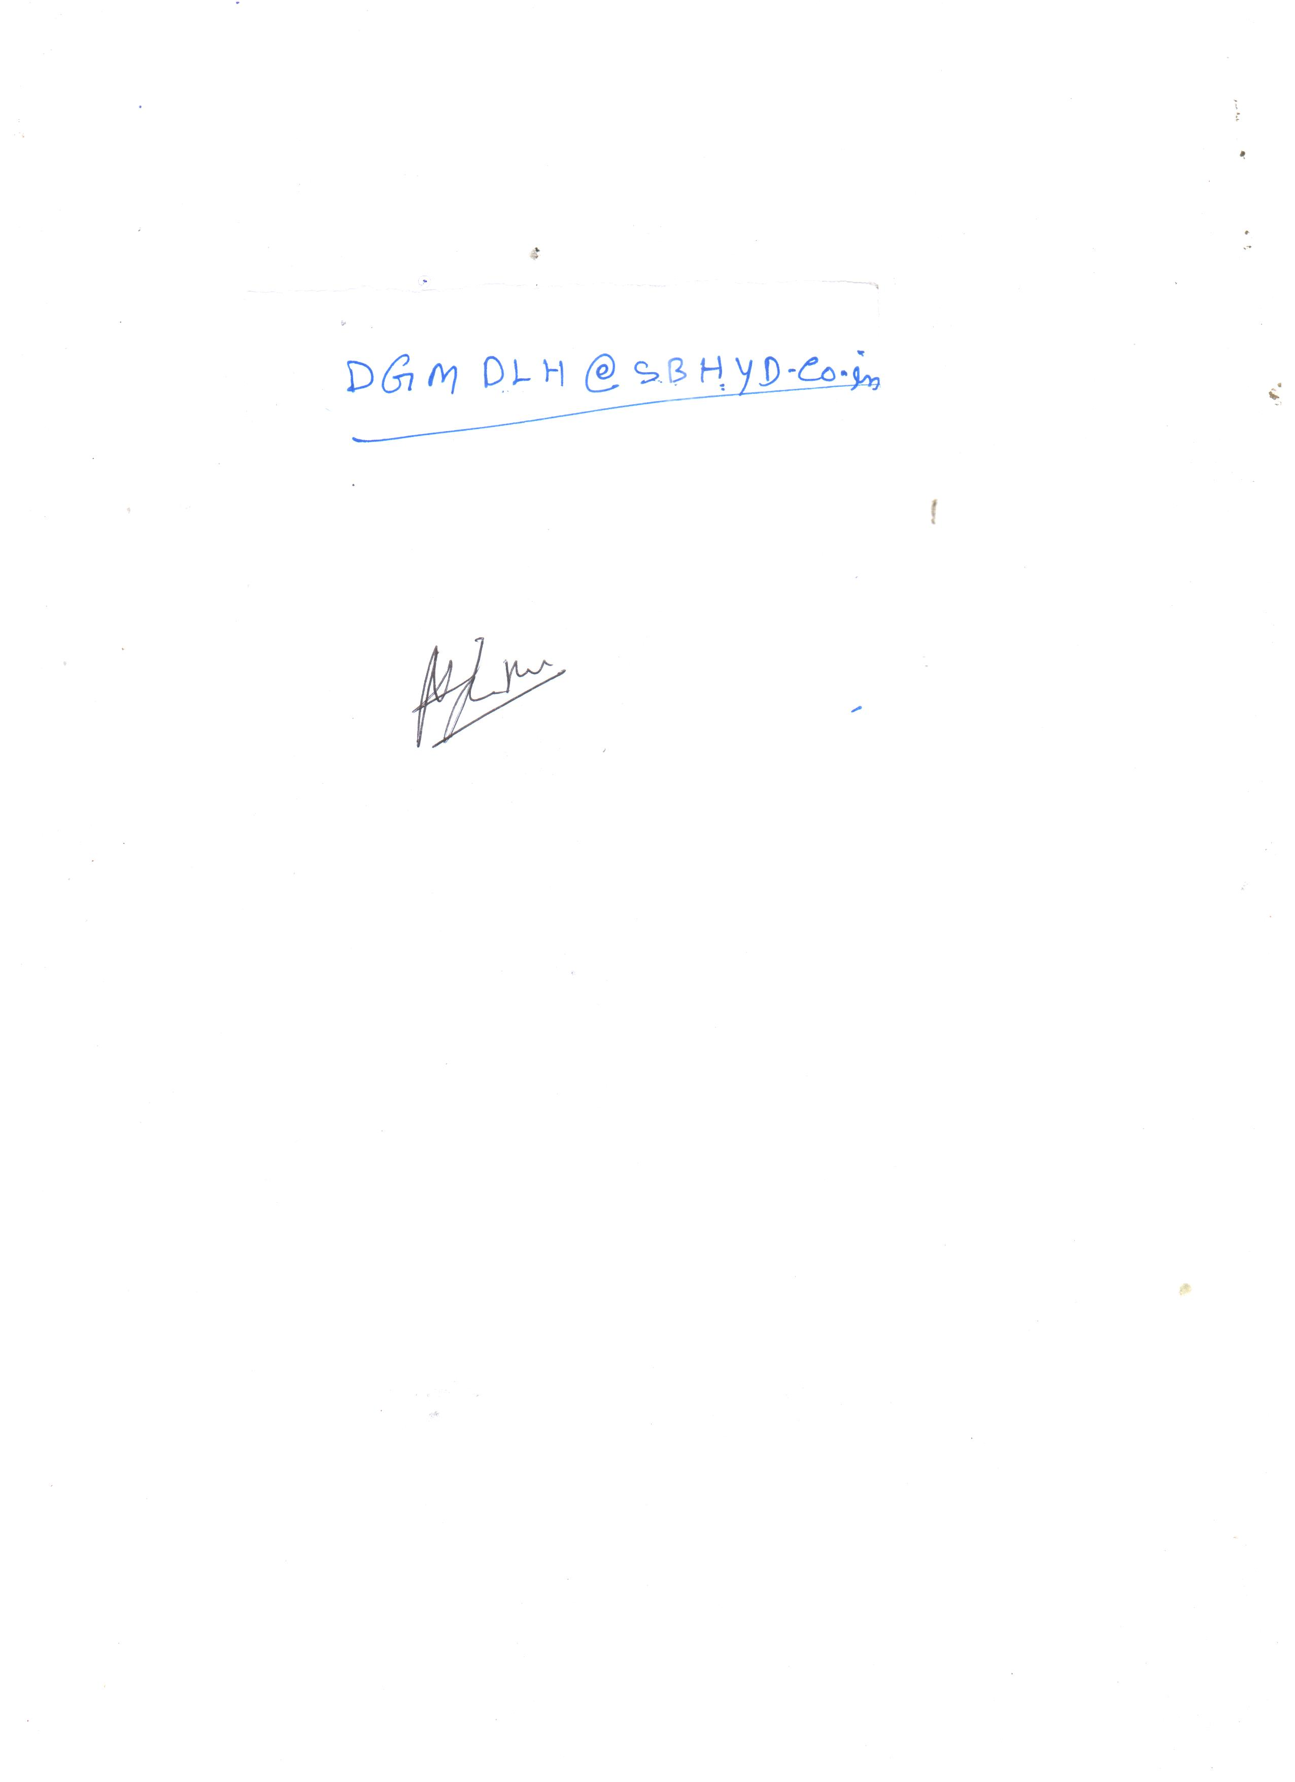
“Awaaz India”

